Pre-requisite - Java Knowledge
Stage 1 - API testing and api automation using testng/junit
Stage 2 - Framework - Cucumber
Stage 3 - OpenAPI Generator and advanced techniques (will be covered between 1 & 2)

- API - Application Programming Interface
A mechanism to enable two software components to communicate with each other.

Easily understand it - architecture of server and client
Server - database that holds the stock details and its price
Client - the mobile app

- Ways of API
  - SOAP
    - Less flexible than that was widely used in the past. Client and Server exchange messages using XML
  - REST API - Representation state transfer
    - The clients send the request to the server as data.
    - The server uses the client's input to start the internal function and return the data
    - Set of functions/methods → GET, POST, PUT, PATCH, DELETE, etc
    - Statelessness. Server does not store client data between requests.
  - Wep API/Web Services (persistent connection)
    - Application processing the interface between web server and web browser
    - All web service are API but not all API are webservice
  - GraphQL
    - A query language that helps developers with multiple query abilities.
- REST API
- Methods - Select/Update/Delete/Create - (GET, POST, PUT, DELETE, PATCH, HEAD, OPTION)
- URL - BASEURL/RESOURCE
- Request headers & body - depends on the request
- Response
  - Response code (1xx - informational, 2xx - success, 3xx - redirectional, 4xx - client error , 5xx-server error)
    - 200 - success
    - 201 - created
    - 404 - Not found
    - 401 - Auth error
    - 403 - Forbidden auth error
  - Response content
4. HTTP Methods
- Get (Path parameter and query parameters)
- Post - create
- Put/Patch - update
- Delete - create
- Petstore API - Find Pet By Id – Path parameter
  - Base URL - https://petstore.swagger.io/v2
  - Resource - /pet/10 (URI)
  - Endpoint → base url+resource
- Petstore API - Find Pet By Id – Query parameter

API Automation - Simple maven project

Installation
- Java installation
  - JDK 17 and above
- IDE
  - IntellJ
  - Eclipse

UpperCamelCase - MyProject
lowerCameCase - myProject
Naming convention
Project - UpperCamelCase
Package - lowercase
Class - UpperCamelCase
Methods & variable - lowerCameCase

Steps to automate the rest api

Maven - Build management tools
- pom.xml - Project Object Model
  - Easily run using CLI - maven phase/goal/life cycle
  - Goals - to generate jars, deploy it in pipeline
  - Dependencies (jar) and their dependent jar will be configured automatically
  - Java compiler - can also be easily configured here

- Create a Maven project
  - Group ID - com.expleo
  - Artifact ID - Project name
- Add dependencies
  - Rest assured - https://mvnrepository.com/artifact/io.rest-assured/rest-assured/5.5.6
  - Testng - https://mvnrepository.com/artifact/org.testng/testng/7.11.0
  - Jackson-databind - https://mvnrepository.com/artifact/com.fasterxml.jackson.core/jackson-databind/2.20.0
- Create a test package and test class
- JsonNode vs JsonPath vs Pojo class
  - Jsonnode - Json hierarchy then it can used but not typed cast properly
  - Jsonpath - json expression - faster but not typed cast properly
  - Pojo class - Used widely for automation & properly type cast
- Pojo class
  - Class/Model - It is a blueprint or type, or template from which object are created
  - Object
    - Object is an instance of a class
    - Every Object has its own state (non-static variable) and behavior (non-static method)
- Why swagger/OpenAPI
  - APIs are like a contract between clients and server
  - swagger/OpenAPI - blueprint for that contract - it gives the information about endpoints, input required, output comes.
  - Automation tester → use the blueprint - generate models, validate response, and design the automation framework
- Open API specification - 3 sections
Can be prepared in JSON or YAML
  - Meta information
  - Path items
    - Parameters
    - Request bodies
    - Response
  - Reusable components (if it is reusable then below items can be mapped here)
    - Schemas (data models)
    - Parameters
    - Response
- OpenAPI specification & its validation
  - Openapi & info
  - Servers
  - Paths & operations
    - Parameters
    - Responses
  - Reusable components
- Every @Test should have minimum one assertion

Day 3

- Actual Order used widely in the market (from testing perspective)
  - Get the swagger document
  - Build the OpenAPI Specification (yaml)
  - Use OpenAPI Generator to generate the model for automation testing
  - Build your maven project with all @Test methods for testing the API request using the model generated

- OpenAPI Generator
  - Open source - automatically generates the client libraries, server stubs, api documentation and models from an openapi yaml/json
  - 50+ languages
  - Integrates with maven, gradle or CLI
Key benefits:
- Eliminates manual model and client side coding
- Custom template
- Generate the model using OpenAPI generator - CLI
Jar available → https://mvnrepository.com/artifact/org.openapitools/openapi-generator-cli/7.16.0

java -jar openapi-generator-cli-7.16.0.jar -i petstore.yaml -g java -o ./generated-model

  - -i → provide the openapi.yaml (openapi specification)
  - - g → java
  - -o → output directory
  - - model-package → where the pojo (model) class should be kept
  - –global-property- models → generates only the model
  - modelDocs=false
  - modelTests=false
- Just use the model created to run with the existing project
  - src/main/java/org/openapitools/client/model

Day 4

- Git →
Git is a free and open source distributed version control system

Architecture
Project (in local machine) → local repo (local machine)--> remote repo (github, aws code commit, bitbucket, gitlab)

Git concepts →
modified - staged - commit

Command to update code to github remote url
- git init → initialize local repo
- git add . → stage the files required to be committed
- git commit -m “message” → update the local repo
To update remote
- git remote add origin https://github.com/balaji-githubstore/java-api-automation-expleo-oct-2025.git - register the remote url with name origin
- git push -u origin master

- Git API
  - List repositories for the authenticated user
  - Create/Update/Delete
- Verify List repo for auth user is working in postman/basic rest assured test
- Create OpenAPI Spec for list repo for auth user - /user/repos
- Required fields:
  - Defined required - listed field are mandatory
  - Not defined required - optional → if json object {} → still it gets passed
  - Required inside the property → might throw error in latest version of open api - because it is considered as invalid
  - Required (for path/query/header) → required: true → can be defined directly
- OpenAPI Spec with various security

BDD Framework - Behaviour Driven Development
- Actual BDD - Understanding the requirement
- Modified form of the BDD - ATDD - Acceptance test driven development - Writing the acceptance testing

BDD Framework
- Python - Jbheave
- C# - ReqnRoll
- Java & javascript – Cucumber

Day 5

Cucumber Architecture

Feature (.feature) → Step definition (.java)

Steps to create a BDD framework
- Create a Maven project
  - Add groupid and artifact id
- Add dependencies
  - Cucumber-java - https://mvnrepository.com/artifact/io.cucumber/cucumber-java
  - Cucumber-testng - https://mvnrepository.com/artifact/io.cucumber/cucumber-testng
  - Rest assured - https://mvnrepository.com/artifact/io.rest-assured/rest-assured/5.5.6
  - Lombok - https://mvnrepository.com/artifact/org.projectlombok/lombok/1.18.42
  - OpenAPI - swagger-request-validator-restassured
  - OpenAPI - swagger-parser
  - Picocontainer -
- Feature file
  - Provide feature header
  - Provide description
    - Unformatted description
    - Formatted description
In order to [application goal]
As a [role]
I would like [visible change]

- Add Scenario
  - Provide Scenario title
  - Minimum one given, when, then
Given - [Prerequisite]
When [Actions]
Then [Verification]

- Add RunnerTest using TestNG and connect feature and add missing step defn
- Step parameterization
  - Reduce duplicates in the step definition
  - Code reuseability
- Scenario outline
  - Reduce duplicates in the feature file
  - One Scenario - multiple sets of test data
- Background
  - Use it only when you have repeated given for all scenarios in a single feature then use background otherwise avoid it.

- Cucumber options –
  - dryRun - to find the missing step defn
  - Publish - to publish report
  - Plugin - to generate locally
  - tags - and, or, not
- Datatable
  - Sending tabular data to one steps defn
- Datatable with scenario outline

Adding automation work:
- src/main/java
  - com. expleo. Config → handle ConfigReader, TokenReader
  - Com.expleo.helpers → GitHubAPIHelper → Actual HTTP method call happens and response will be provided
  - Com.expleo.model. → POJO class
  - Com.expleo.utils → GitRequestSpecBuilder, OpenAPIValidator → RequestSpecBuilder object that is required for building request body
- src/main/test
  - com.expleo.context → using dependency injections
  - com.expleo.hooks → Setup - before and after scenario , reports
  - Com.expleo.Runner
  - Com.expleo.Steps
- Lombok Libraries
  - Plugin for IntelliJ -
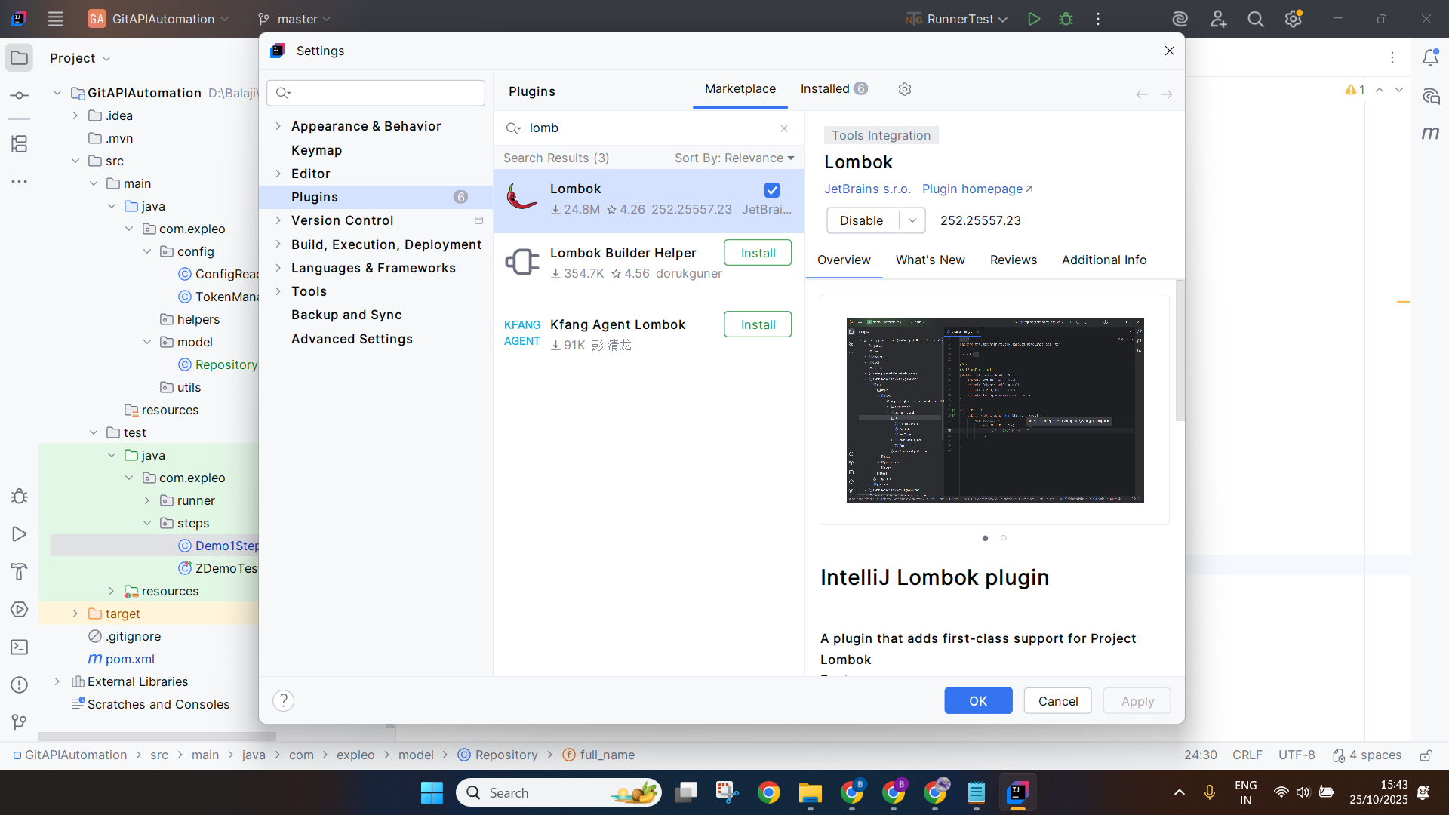
  - Add dependencies - https://mvnrepository.com/artifact/org.projectlombok/lombok/1.18.42
  - Lombok – will take care creating getters and setter method for all fields declared inside the POJO class
  - Create class
@Data
@Builder
@NoArgsConstructor
@AllArgsConstructor

public class Repository {
private Long id;
private String name;
private String full_name;

}

- Added
  - Utils package
    - GitRequestSpecBuilder
    - OpenAPIValidatorUtils
- Added ZZZDemoTest → UnderstandGitHelperRun()--> not part of the framework
- Added the ListRepositories.feature
  - Scenario: List all repositories for authenticated user
- Added the TestContext for sharing the response between class, methods
- Added hamcrest assertions

Important concepts – (To improve Reusability, readability, maintenance)
- Step parameterization - code reuse
- Scenario outline - one scenario - multiple sets of test data
- Background - repeated given
- Datatable - Tabular data

Category obj1=new Category();
Category obj2=new Category();

obj1.setId(3000);

System.out.println(obj1.getId());
System.out.println(obj1.getName());

System.out.println(obj2.getId());
System.out.println(obj2.getName());

Day 3
- Add pet
- FindPetByStatus - binding to pojo model
- OpenAPI Generator → model generator (POJO class)
- We model generated using openAPI on the existing test method
- Git API
- Git or Setup for Cucumber framework

Day 4
- Git API - list repo for users, create, update, delete
- Add automation for the list repo for the user
- Create an openAPI spec and run the automation with validation
- Create a Model using the open api spec (YAML) —> do it as a task after the session
- Cucumber framework - BDD Concepts

Day 5
- Will concepts of BDD
- Design of the actual framework
- Mock API

Day 6:
- List all repos for auth users
- Framework will be completed
- Chaining the API → create-delete
- Mock API using openAPI - mock api calls

Important notes:
- Security types and usage in OpenAPI Spec
openapi: 3.0.3
info:
title: GitHub API (User Repos)
version: 1.0.0
servers:
- url: https://api.github.com

paths:
/user/bearer:
get:
security:
- tokenAuth: []

/user/basic:
get:
security:
- basicAuth: []

/user/api-key:
security:
- apiKeyAuth: [ ]

/user/oauth:
security:
- oauth2Auth:
- repo
- user

components:
securitySchemes:
tokenAuth:
type: http
scheme: bearer
bearerFormat: "token"

basicAuth:
type: http
scheme: basic

apiKeyAuth:
type: apiKey
in: header
name: X-API-Key

oauth2Auth:
type: oauth2
flows:
authorizationCode:
authorizationUrl: https://github.com/login/oauth/authorize
tokenUrl: https://github.com/login/oauth/access_token
scopes:
repo: Access to repositories
user: Access to user profile

Assignments:
Task 1:
- Use OpenAPI Spec git created in session and generate model using open api generator

Session Code - https://github.com/balaji-githubstore/java-api-automation-expleo-oct-2025.git

Github API for practice:
https://docs.github.com/en/rest/repos?apiVersion=2022-11-28

- List repositories for a user
- List repositories for the authenticated user
- Create a repository for the authenticated user
- Update a repository
- Delete a repository

Reference
- OpenAPI Keywords -
  - Core OpenAPI Structure Keywords
  - Path & Operation-Level Keywords
  - Schema Keywords (based on JSON Schema)
  - Components Keywords
  - Common Data Type Keyword
- Core OpenAPI Structure Keywords
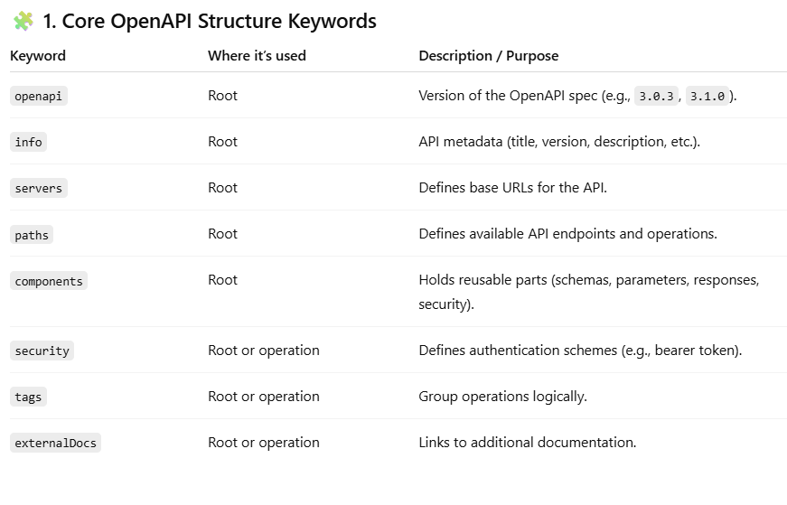
- Path & Operation-Level Keywords
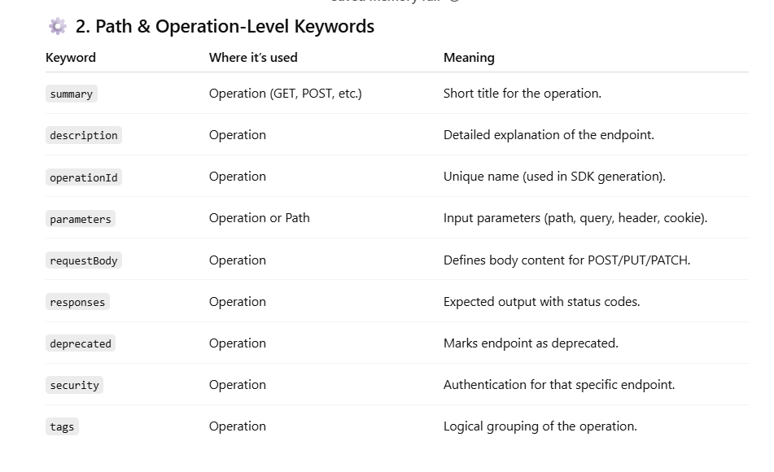
- Schema Keywords (based on JSON Schema)
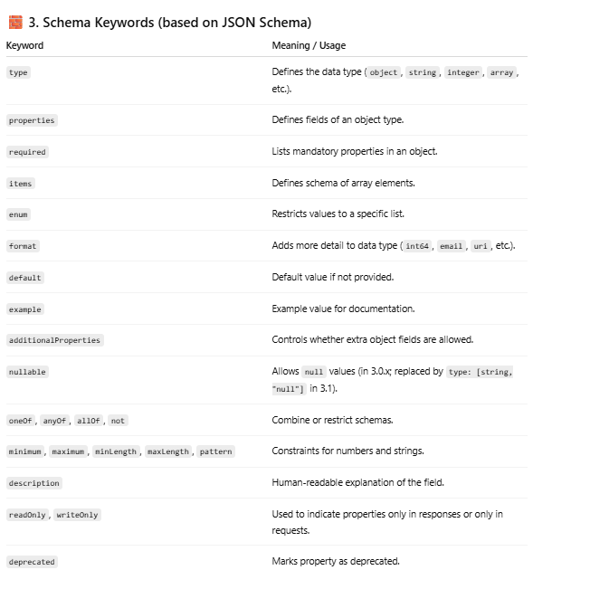
- Components Keywords
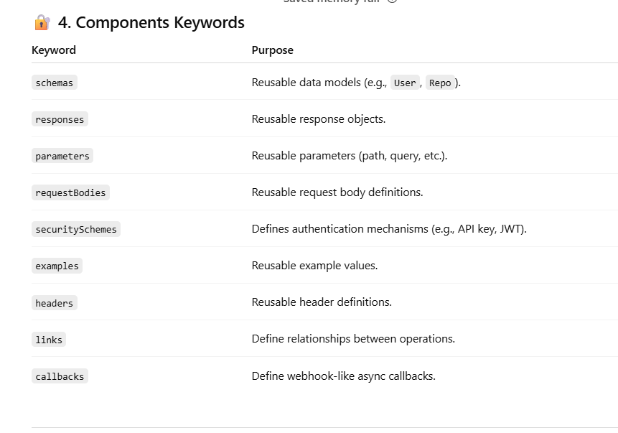
- Common Data Type Keywords
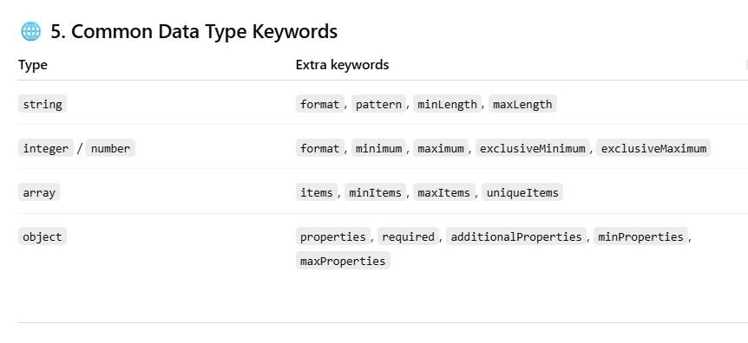
- Open API Spec - Array possible validations

minItems: 1
maxItems: 10
uniqueItems: true
nullable: true
—-----------------
items:
- type: string
- type: number
additionalItems: false
—-----------------
items:
type: string
enum:
- small
- medium
- large

—-----------------
Combining with allOf, oneOf, anyOf

items:
oneOf:
- type: string
- type: number
—-----------------

- Open API Spec - float/int/double/string
uniqueItems: true
—-----------------
items:
type: integer
minimum: 0
maximum: 100
—-----------------
items:
type: number
format: float
minimum: 0.0
maximum: 100.0
—-----------------
exclusiveMinimum: true
exclusiveMaximum: true
—-----------------
html_url:
type: string
format: uri

